**Scenario Example:**

Lily is going to an interview for an HR manager position at Salesforce. She would like to make a good impression. Please help Lily choose an appropriate outfit and explain to her why she should wear that attire.

| Top | Bottom & Shoes |
| --- | --- |
|  |  |

*I helped Lily choose a professional business outfit because she is interviewing for an HR manager position. The HR manager position will manage other staff and help any people with HR-related questions. Salesforce is a cloud-based service company that provides a complementary suite of enterprise applications focused on customer service, marketing automation, analytics, and application development.*

**Scenario 1**:

Rachel is a rising freshman in high school and is interested in an internship. Well, great news! While searching online, Rachel came across a program called MYEEP, and she decided to apply to become an MYEEP participant. Fast forward to 1 month later, Rachel received an email regarding an interview. Rachel was planning to wear a hoodie to the interview. However, could you please help Rachel choose which attire is most appropriate for this setting? Please also state below why you decided on that attire type.

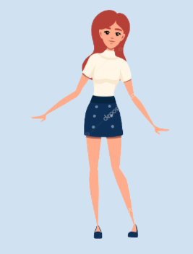

I decided to choose Casual wear because I believe that MYEEP is an internship that accepts everyone even with how low their income or quality of clothes are. However, wearing a hoodie isn’t the best choice because you might have to show that you actually care about the job, instead of wearing the worst choice you have. Even though MYEEP accepts all people, it is important to show that you care with at least casual or business casual wear.

**Scenario 2**:

Jeff has just completed law school and wants to start his work as a lawyer immediately. He sends his resume and cover letter to the law firm in his city. A few days later, he receives an email from the firm offering him an interview for the position. Jeff is ecstatic, of course, but he doesn’t know what to wear. Help him out by selecting the type of attire that would be most appropriate for his interview. Provide reasoning for your choice.

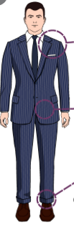

I decided to choose Business Professional because it also showed how he really cared for this job. Also I think applying for a law firm is a very professional job, and because of that, business professional is a good fit. Business casual just doesn’t fit because that just doesn’t represent what a law firm does, which is being as professional as possible.

**Scenario 3**:

Alex is going to an interview for a part-time Starbucks Barista position. Alex is currently a 2nd-year college student at San Francisco State studying accounting. Can you help Alex choose an attire that will help represent who he/she/ they (is/ are)? Of course, you would also want to help Alex choose appropriate attire for the interview.

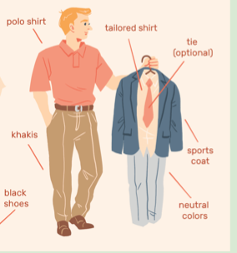

For Alex, I would choose Business Casual because Starbucks is a coffee brand that is a business. Also working at Starbucks is also pretty low-end and low-risk, so not overdoing it, while also still showing that you care is a good idea for this interview.